Nadine Mansour

Project 4: Stacks

nadine.mansour2@rockets.utoledo.edu

October 26, 2017

Project 4 Part 1: Reverse Strings

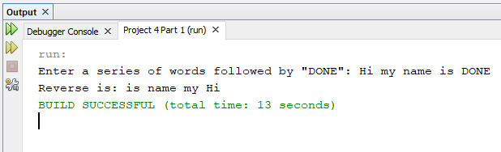

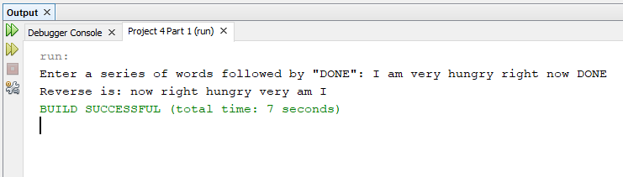

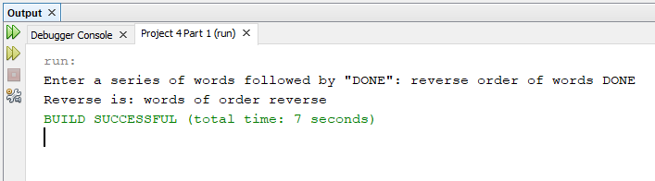

Project 4 Part 2: Evaluate Expressions

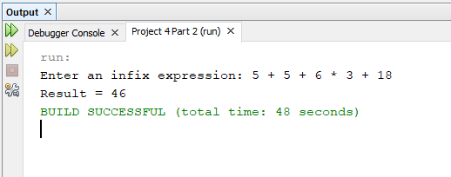

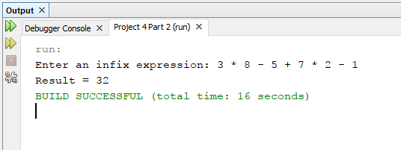

Extra: Division

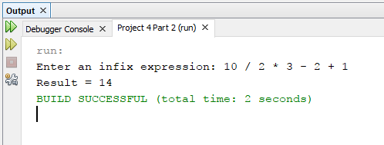

Special Cases

Too many operators

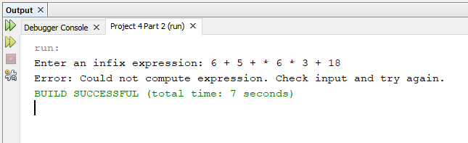

Too many operands

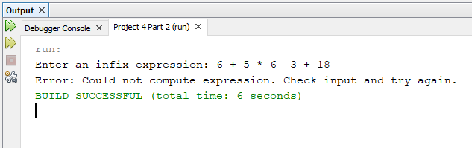

Illegal Operator

